The Jam Trolley – September 2024

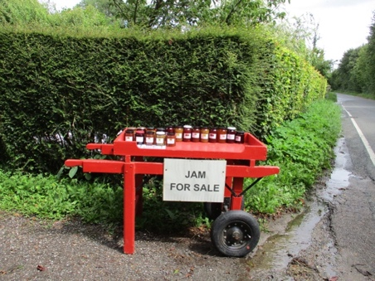

We have a range of giftware to complement our range of jams. The woodwork items have been made by my husband. Please order from this form, thank you.

Julia & Chris Goodwin [southacres@btinternet.com](mailto:southacres@btinternet.com) 01799 584310

|  |  |  |
| --- | --- | --- |
| 1. | The Jam Caddy with 3 x 227g (8oz jams) | Select your jams (subject to availability) from:  Damson  Victoria Plum  Greengage Plum  Blueberry & apple  Strawberry  Seville Orange marmalade  Lime marmalade  Lemon marmalade  Lime & lemon marmalade  Mandarin marmalade  Clementine & ginger marmalade  Four fruit marmalade  Mixed Berry  Mango & ginger  Rhubarb & ginger  Ruby Grapefruit.  Pumpkin & ginger  Mulberry  Peach  Apricot  Nectarine  Raspberry & apple  Lemon & ginger marmalade  Fig & apple  Green fig  Price for caddy and 3 jams. £18.00 |
| 2. | Bottle Caddy with opener | Price for bottle caddy (no bottles supplied)…£20.00 |
| 3. | Wooden Garden Trug | Price for trug. £23.00 |
| 4. | Jelly | Hex 12 oz jars £5.00– 227g (8oz) £4.00 ea  Quince  Crab Apple  Damson  Elderflower  Medlar  Grape  Mulberry  Mulberry & apple  Apple & rose petal |
| 5. | Jams | Large 320 to 450g Marmalades & Jams £4.30 ea |
|  |  | Med 227g (8oz) Marmalades and jams £3.50 ea |
|  |  | (Flavours as above) |
| 6. | Alcoholic Marmalades | Price £5.50 – making restricted to special occasions |
|  | Orange & Whiskey |  |

|  |
| --- |
| Your details: |
| Address |
|  |
|  |
|  |
| Email address: |
| Tel No. |

|  |  |  |  |
| --- | --- | --- | --- |
| Product | Size | Number | Sub total |
|  |  |  |  |
|  |  |  |  |
|  |  |  |  |
|  |  |  |  |
|  |  |  |  |
|  |  |  |  |
| Total |  |  |  |

Note: All products are subject to availability. Postage & packing at extra cost.